**"КИЇВСЬКИЙ ФАХОВИЙ КОЛЕДЖ ЗВ’ЯЗКУ"**

**WORK-CASE №2**

з дисципліни «Операційні системи»

Виконали: студенти **3** курсу, групи **КСМ-13А**

**Засенко Олександр**

(прізвище та ініціали)

**Дзюбенко Дмитро**

(прізвище та ініціали)

**Сторожук Костянтин**

(прізвище та ініціали)

Київ  2023

**ЗМІСТ**

1 Installing a virtual machine 3

2 Setting up a virtual machine in a virtualbox 4

1. Adding equipment 5
2. Network connection 6

3 Ability to work with external media 7

Conclusions 8

Links to original sources 9

To install the linux system, you need to download the system from the developers' website in .iso format. You can learn about choosing an environment on thematic sites and choose another xfce/kde for yourself.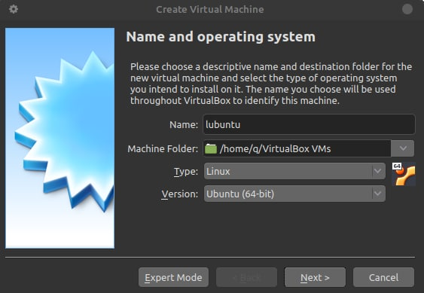

Pic 1. Selection of the version and the path to the files.

A 2006 model PC is enough for a comfortable life.

But Linux, like its components, also evolves and becomes more difficult. The same Ubuntu will now not work normally on a device with less than 4 GB of RAM. That is why we need lightweight distributions that are still trying to please users with outdated hardware.

In order to comfortably use the operating system, let's fiddle with the settings a little. Let's choose video memory (the best option is from 48). Let's turn on VBoxSVGA and turn on 3D acceleration, as in the figure.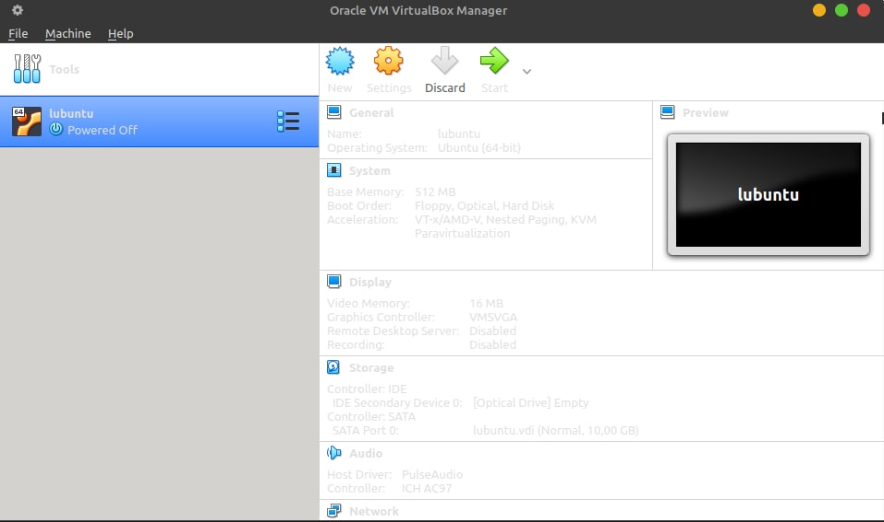

Pic. 2. Selection of the machine.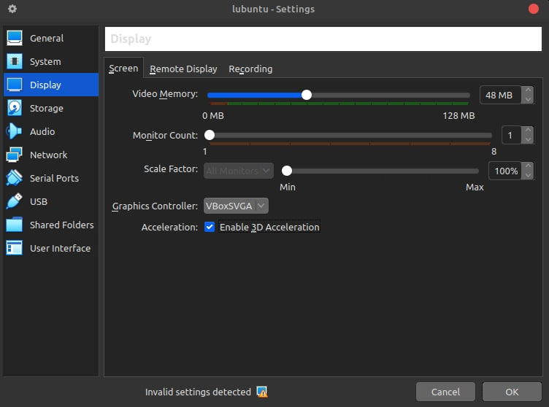

Pic. 3. Machine settings

A virtual machine includes adding new virtual disks, increasing the amount of RAM, or providing access to physical devices such as printers or USB devices.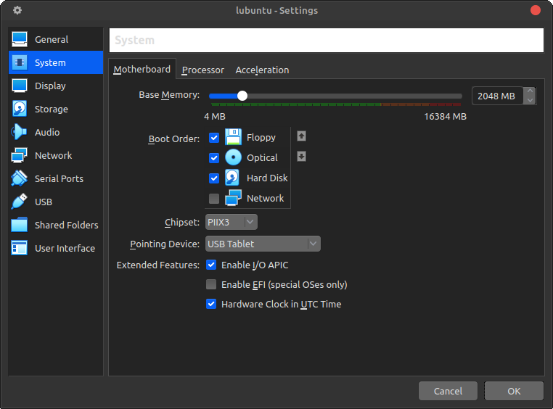

Pic. 4. Adding equipment

The procedure for selecting and adding hardware to a virtual machine:

* **Select a virtual machine**
* **Open the VM settings**

**Adding equipment:**

* **Processor (CPU)**
* **RAM**
* **Disk space**
* **Network adapters**

Save the settings

To configure the network and connect to Wi-Fi hotspots in VirtualBox, you need to perform the following steps:

1. Stop the virtual machine
2. Open the VM settings
3. Go to the "Network" section
4. Select "Attached to"
5. Select your Wi-Fi card
6. Save the settings
7. Start the virtual machine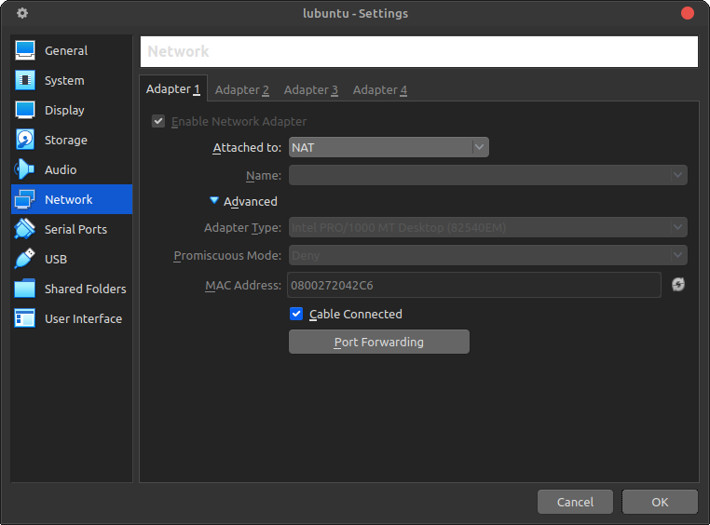

Pic. 5 Connecting to the network

VirtualBox has the ability to work with external media, such as USB flash drives, external hard drives, CD/DVD drives, and others.

Here are the steps to work with external media in VirtualBox:

1. Download and install the VirtualBox Extension Pack
2. Start the virtual machine
3. Go to VM settings
4. Go to the "USB" section
5. Add USB filters
6. Connect the external device
7. Start the virtual machine
8. Use an external device

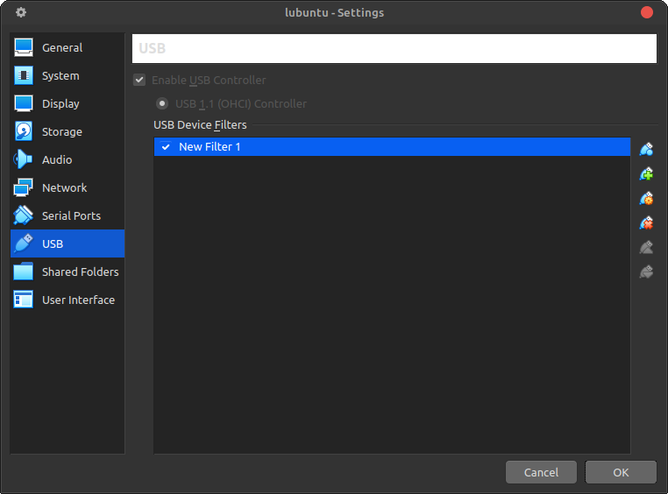

Pic. 6. Adding external media

**Conclusions**

**Links to original sources**

1. [Electronic resource] – Resource access mode:
2. [Electronic resource] – Resource access mode:
3. w3schools [Electronic resource] – Resource access mode:

[Git Commit (w3schools.com)](https://www.w3schools.com/git/git_commit.asp)

1. [Electronic resource] – Resource access mode:
2. [Electronic resource] – Resource access mode:
3. [Electronic resource] – Resource access mode: